EXAMPLE MONITORING OUTPUT

Console Output:
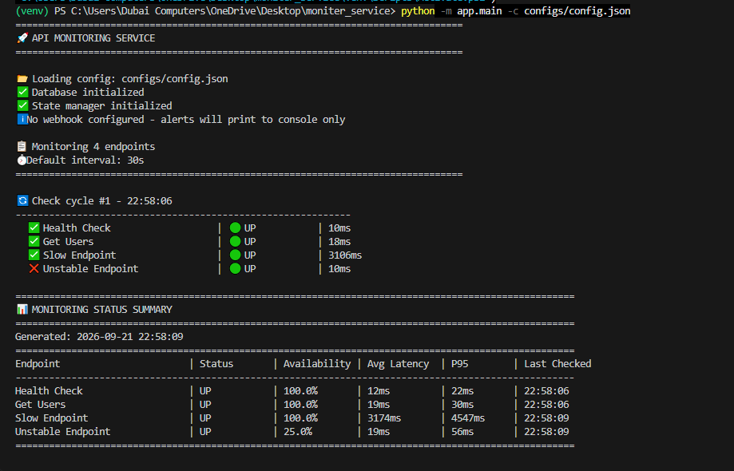
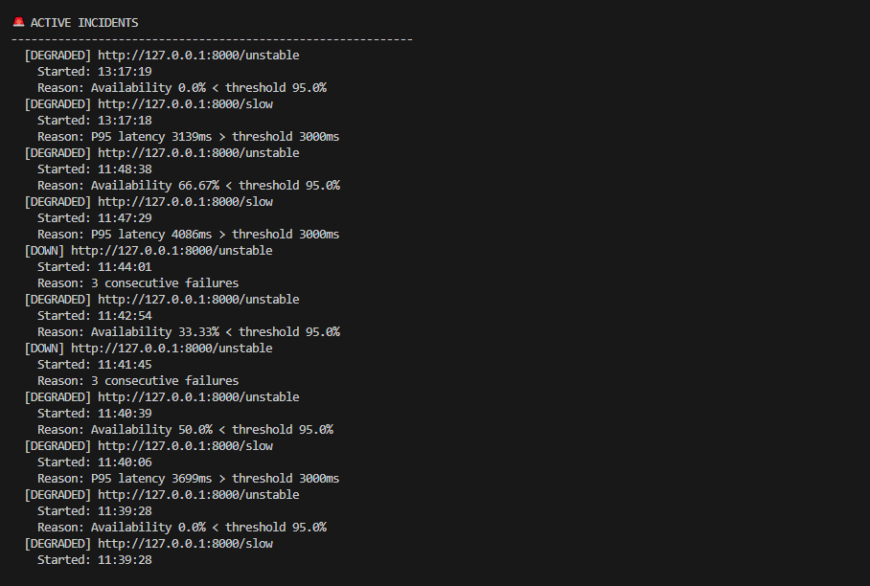

Report File: reports/status_latest.json
{
"timestamp": "2026-09-21T14:30:00",
"summary": [
{
"endpoint": "Health Check",
"url": "http://127.0.0.1:8000/health",
"status": "UP",
"availability": 100.0,
"avg_latency_ms": 45.0,
"p95_latency_ms": 55.0,
"last_checked": "14:30:00"
},
{
"endpoint": "Slow Endpoint",
"url": "http://127.0.0.1:8000/slow",
"status": "DEGRADED",
"availability": 100.0,
"avg_latency_ms": 3200.0,
"p95_latency_ms": 3500.0,
"last_checked": "14:30:00"
}
],
"active_incidents": [
{
"id": 1,
"endpoint": "http://127.0.0.1:8000/slow",
"incident_type": "DEGRADED",
"started_at": "2026-09-21T14:30:00",
"reason": "P95 latency 3500ms > threshold 3000ms"
}
],
"total_endpoints": 4,
"endpoints_up": 3,
"endpoints_degraded": 1,
"endpoints_down": 0
}

Report File: reports/status_latest.csv
endpoint,url,status,availability,avg_latency_ms,p95_latency_ms,last_checked
Health Check,http://127.0.0.1:8000/health,UP,100.0,45.0,55.0,14:30:00
Get Users,http://127.0.0.1:8000/users,UP,100.0,52.0,60.0,14:30:00
Slow Endpoint,http://127.0.0.1:8000/slow,DEGRADED,100.0,3200.0,3500.0,14:30:00
Unstable Endpoint,http://127.0.0.1:8000/unstable,UP,100.0,38.0,45.0,14:30:00

